Final prototype Link: <https://www.figma.com/file/VVU3vZiAiLwlk55aDNPYtEzU/HWPlanner-Final>

Our prototype A and B have almost the same function but with different UI and operation. Prototype A use the side menu to switchover different pages and prototype B use the back button which is linked with the main menu. Our final prototype use both the side menu and the back button to make it easier to use for every users.

Another important thing for our previous prototypes is the color using. Prototype A and B both use the cool color and we try to make them easy to distinguish between the contents and the background. But in our final prototype, we decided to use the simple white color as the background and the undertint for the contents. This could make the user feel more relax when they using our app.

usability issues table

|  |  |
| --- | --- |
| Issue | How to reserve |
| The sidebar in the prototype was small and information was small | We make the text bigger or provide more options |
| The color scheme is all over the place | We toned them down |
| The layout was kind of jumbled and difficult to understand | We simplify the UI and make it easier to understand |

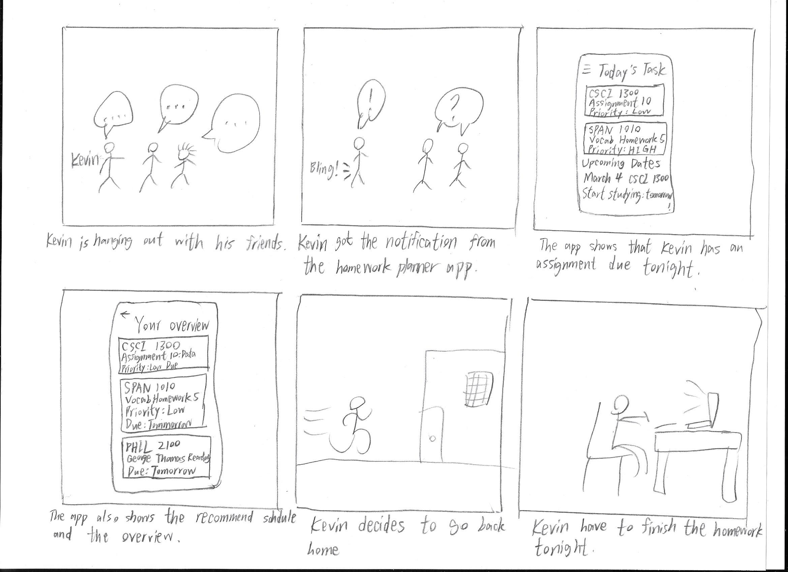The storyboard shows a user called Kevin who is hanging out with his friends. The app gives him the notification to remind him that he still has homework due tonight. He can use the app to overview his assignments and make a schedule for his future plan. Then he decides to go home and do his homework. The video prototype shows how we use the app. The users who use our app will be the students. Our questionnaire and usability tests gave us some really nice feedback to show the users’ interest and they would like to have this app to be used. The previous feedback demonstrate that our app could have a better UI and add the function to help the users remember whether they complete their assignments. In the final prototype, we fixed the problems and made a perfect version of it.

Video Link: <https://youtu.be/gLRtSHvOPKQ>